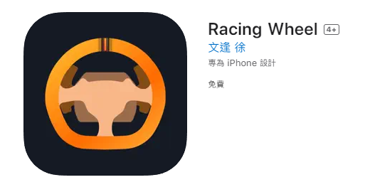
可以在APP商店搜尋Racing Wheel或透過以下連結下載。
You can search for Racing Wheel in the APP store or download it through the link below.

Android APK: https://drive.google.com/file/d/1mmiz-ix2IuQmn0shfzT02z5RVaIx4zZq/view?usp=sharing

Apple store:
https://apps.apple.com/tw/app/racing-wheel/id6451091099

用手機下載APP後允許應用程式使用藍牙並選擇Force Feedback，F107方向盤在藍牙範圍內開機即可被搜尋到，可以在APP調整方向盤的各項設定。

After downloading the APP on your mobile phone, allow the application to use Bluetooth and select Force Feedback. The F107 steering wheel can be searched when turned on within the Bluetooth range, and various settings of the steering wheel can be adjusted in the APP.

