Microsoft Flight Simulator 2020
Joystick V6
Setting steps:
After entering the game, select the OPTIONS:
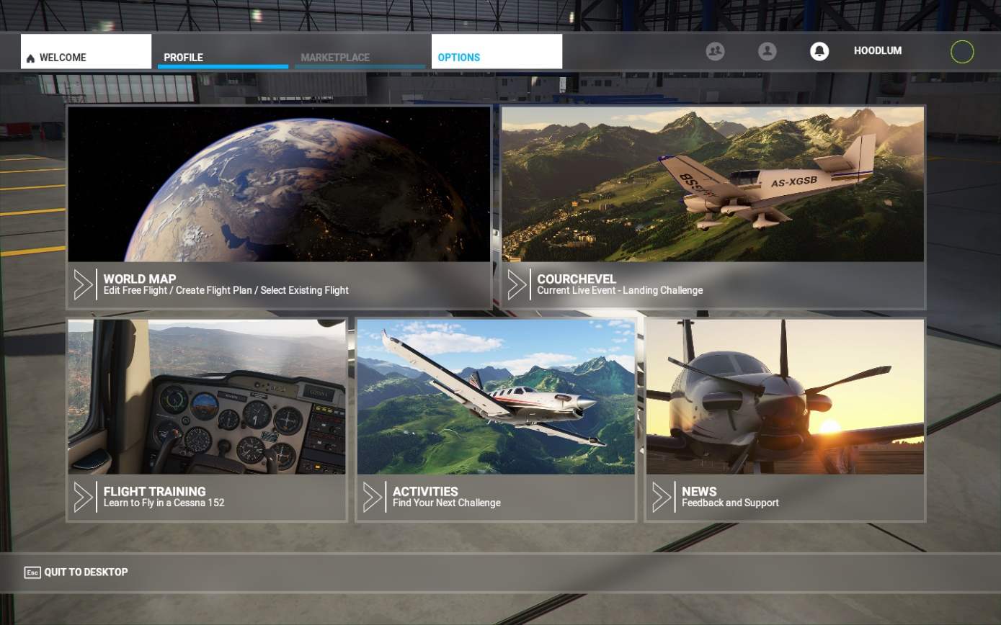

Then got to CONTROLS
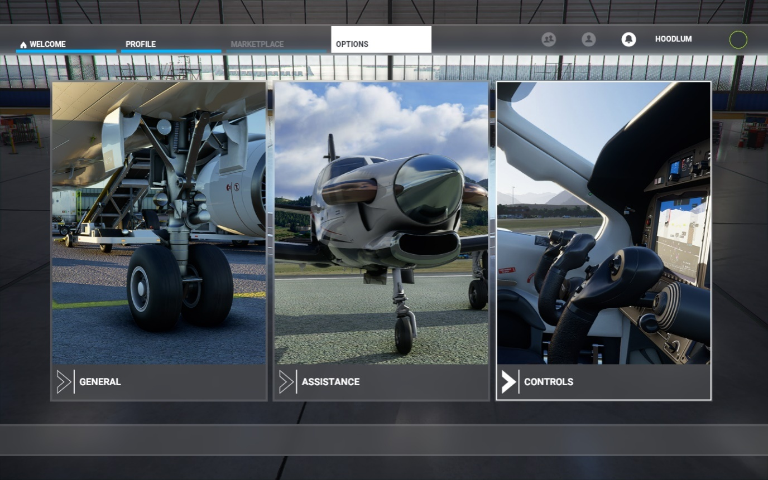
You will see that there is a USB JOYSTICK option which indicate that the V6 flight stick is detected, but there is no default value as shown on below, so it cannot be used in the game
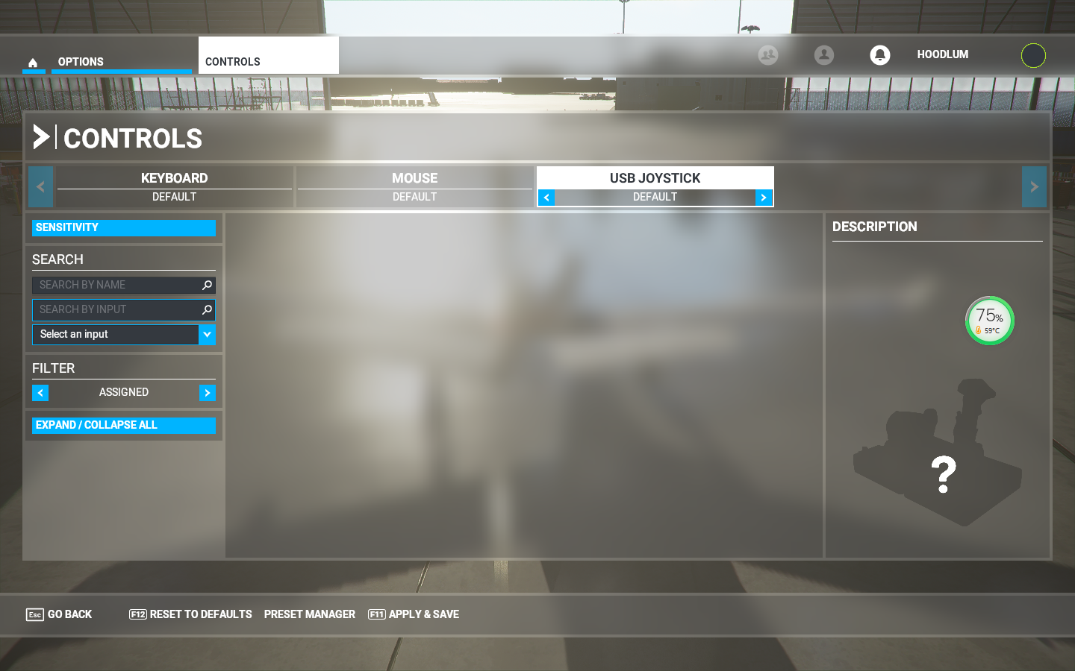
沒有預設值
NO DEFAULT

Please set the FILTER to ALL in order to show all the settable functions
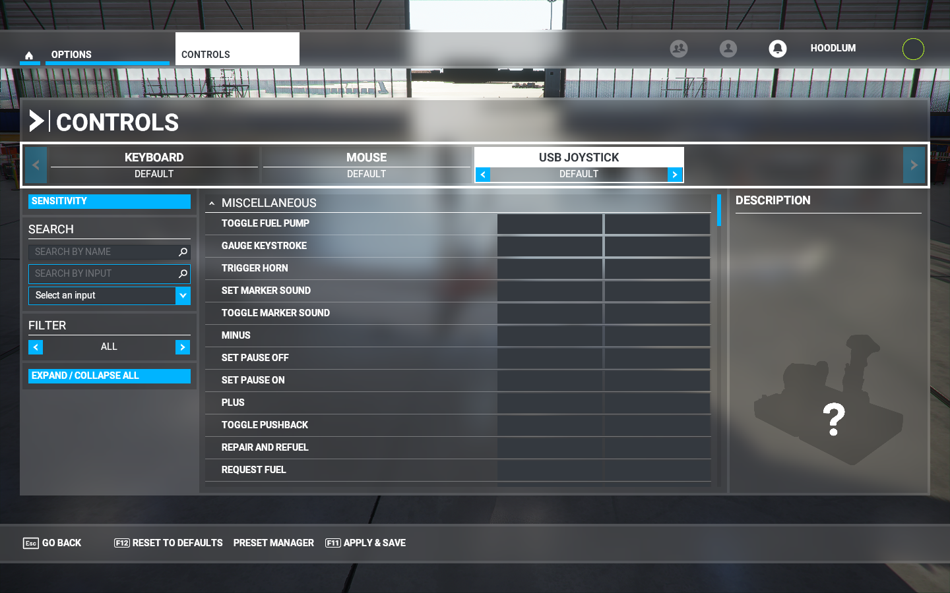
There’stoo many functionsthat can be set in the above picture, so you can click EXPAND/COLLAPSE ALL on the lower left to list only big items
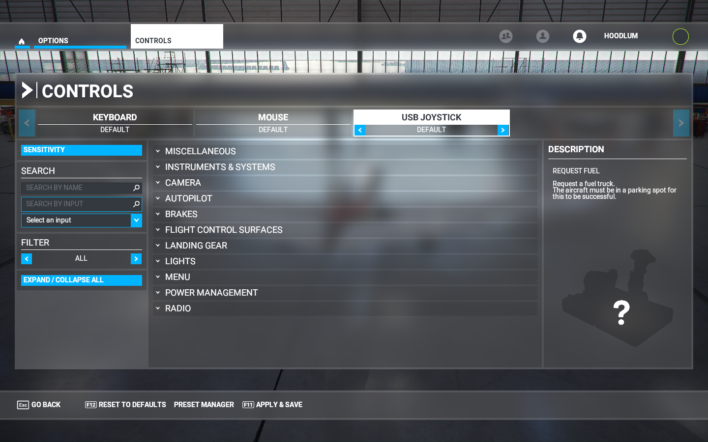
顯示大項目
to show big items

Start to X axis setting: to find FLIGHT CONTROL SURFACES PRIMARY CONTROL SURFACES AILERONS AXIS,Click the red box as shown below to perform the mapping function
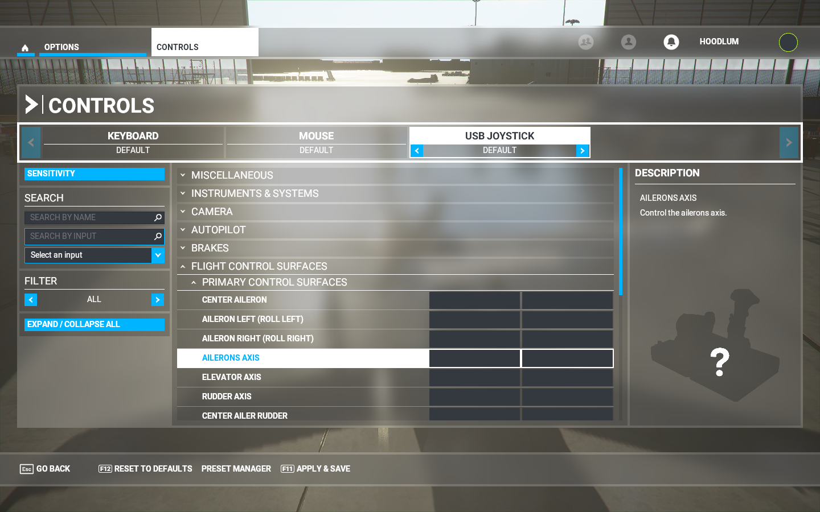
Please click the Red box again, it will reverse white
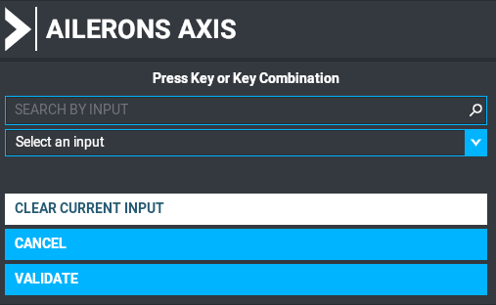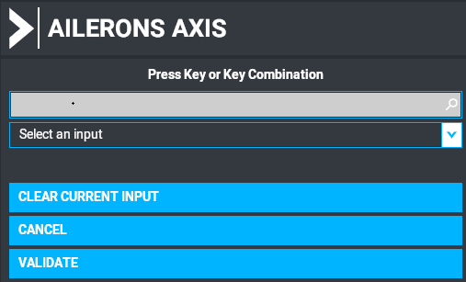

Move the flight stick to the left or right, it will appear the Joystick L-Axis X which means the setting has been successful. If not, please reset it again. Click on the VALIDATE below to complete the setting. The setting will askto save or not in the first time, PleaseclickOKto confirm.
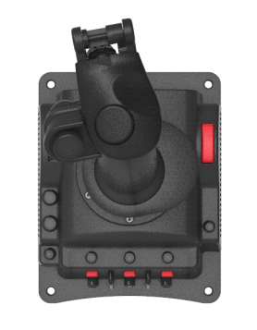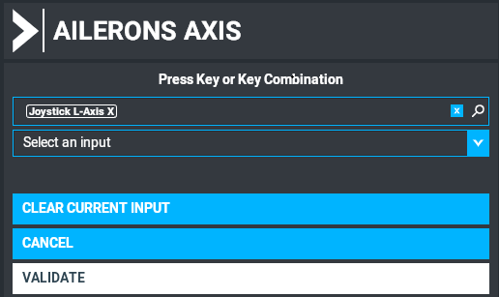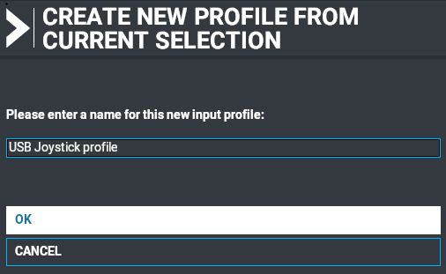

After the setting is completed, you can see that the red box below corresponds to the X axis, and move the flight joystick left and right ,the light bar will follow it
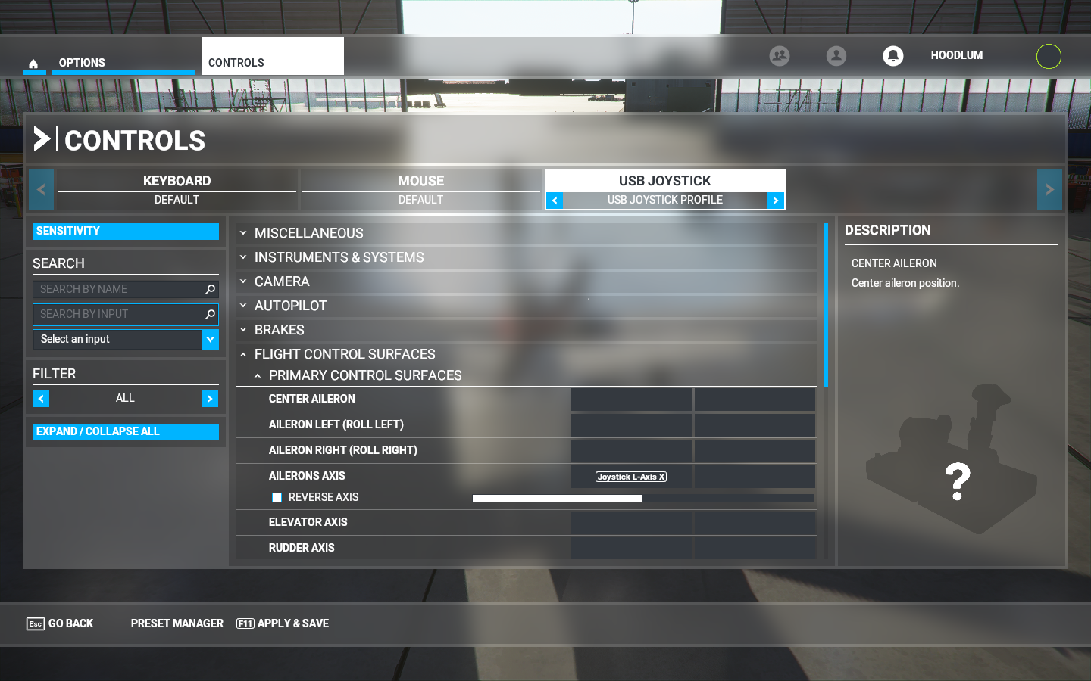
Then follow the above steps to set the following functions :

FLIGHT CONTROL SURFACES
PRIMARY CONTROL SURFACES
AILERONS AXIS | X Axis | 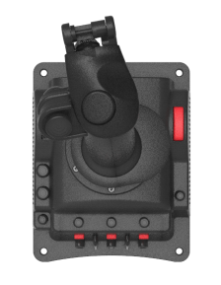  The joystick moves horizontally
ELEVATORAXIS | Y Axis | Move the joystick back and forth
RUDDERAXIS | RX Axis | Rotate the joystick left and right
POWERMANAGEMENT
THROTTLE
THROTTLE1AXIS  GAS | Z Axis | 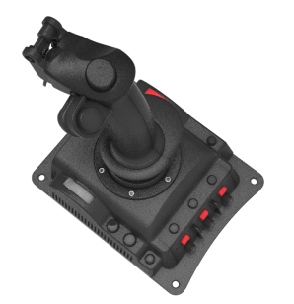  Throttle forward and backward
BRAKES
TOGGLE PARKING BRAKES | 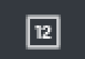  START | 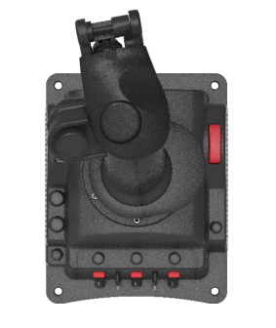  Press the STRAT key
CAMERA
CAMERAMODESWITCH
COCKPIT/EXTERNALVIEW MODE  Cockpit/external camera switch button | C3 | 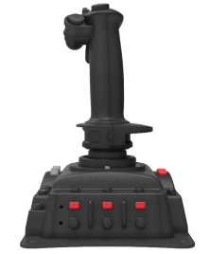  Press C3 key
CAMERA
COCKPITCAMERA
COCKPITQUICKVIEWRIGHT | 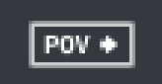  POVright | 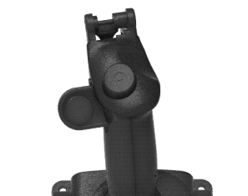  POVright
COCKPITQUICKVIEWLEFT | 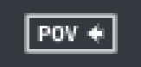  POVleft | POVleft
PREVIOUSPILOTPOSITION | 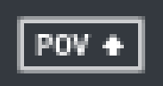  POVup | POVup
NEXTPILOTPOSITION | POVdown | POVdown

The screen shot after settings:

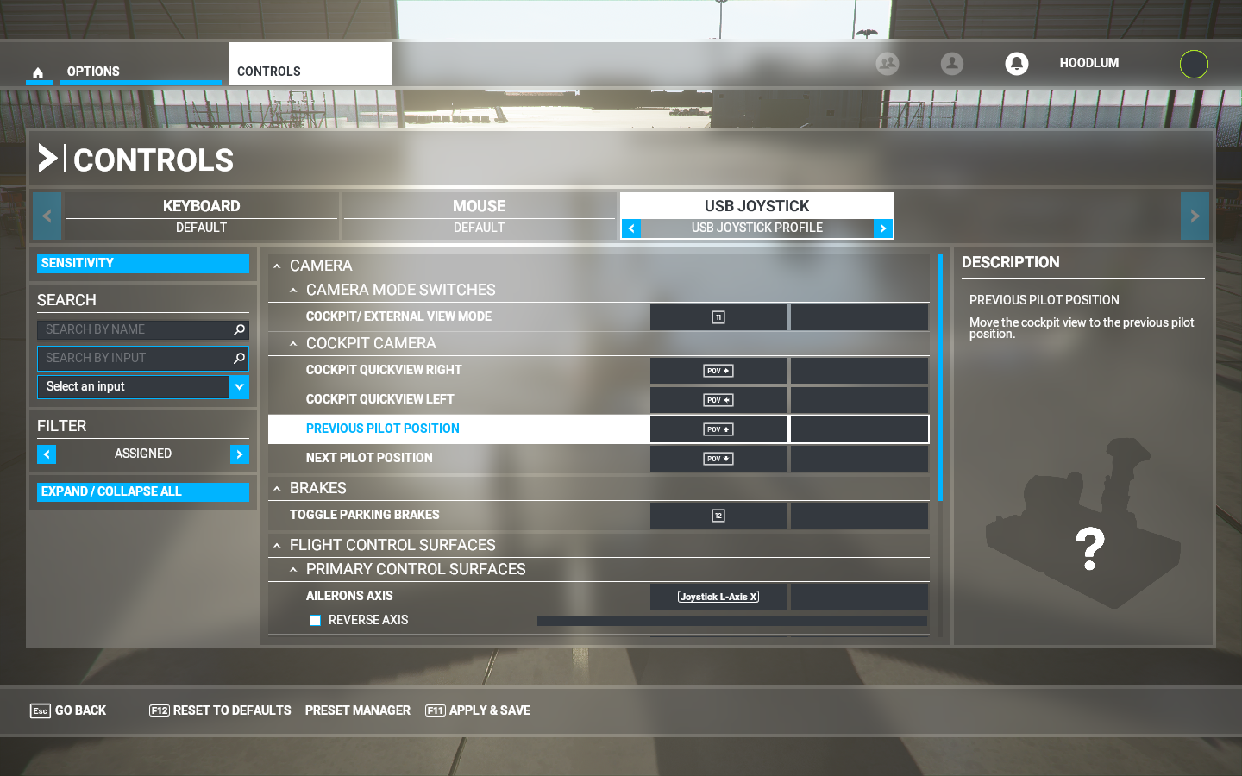

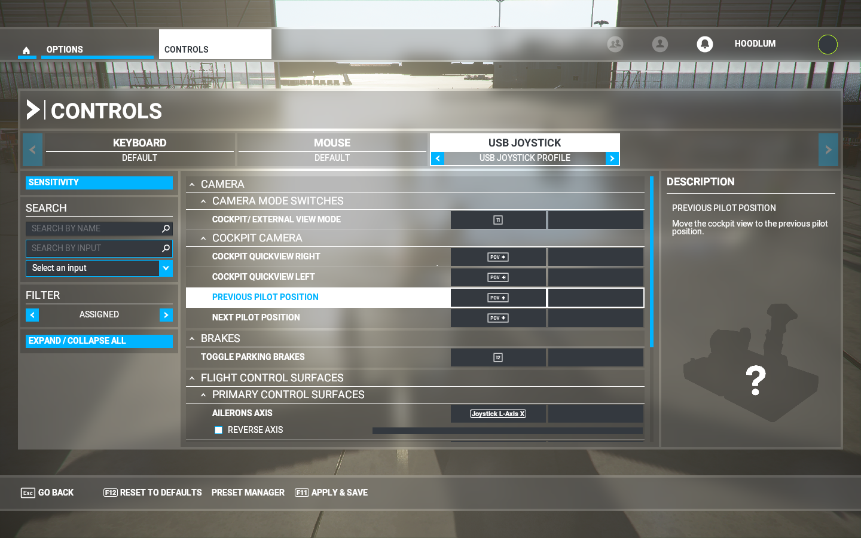

Microsoft Flight Simulator 2020
Joystick V6 設置步驟
進入遊戲後選擇OPTIONS 選項

再選擇 CONTROLS 選項
可以看到有 USBJOYSTICK選項,說明偵測到 V6飛行搖桿,但是因為下面沒有預設值所以遊戲內無法使用
沒有預設值

將左下 FILTER設為ALL,把所有可設置的功能顯示出來
上圖因為可設置的功能太多,可以點擊左下EXPAND/COLLAPSE ALL 只列出大項目
顯示大項目

開始設置X軸,找到FLIGHT CONTROL SURFACES PRIMARY CONTROL SURFACES AILERONS AXIS ,在點擊紅框處進行映射功能
再點擊紅處,變成反白

將飛行搖桿往左或右移動,會出現 Joystick L-Axis X , 表示己映設成功,若不是這個值請重新再設置一次,點擊下方 VALIDATE設置完成,第一次設置會詢問是否存檔,點擊OK即可

設置完成,可以看到下面紅框處己對應 X軸,左右移動飛行搖桿下方光條也會跟著移動
再依上面步驟,依序設置完下面功能

FLIGHT CONTROL SURFACES
PRIMARY CONTROL SURFACES
AILERONS AXIS | X軸 | 搖桿水平移動
ELEVATORAXIS | Y軸 | 搖桿前後移動
RUDDERAXIS | RX軸 | 搖桿左右旋轉
POWERMANAGEMENT
THROTTLE
THROTTLE1AXIS  油門 | Z軸 | 油門前後推
BRAKES
TOGGLE PARKING BRAKES  手剎開關 | START 鍵 | 按下STRAT鍵
CAMERA
CAMERAMODESWITCH
COCKPIT/EXTERNALVIEW MODE  座艙/外部攝像頭切換鍵 | C3按鍵 | 按下C3按鍵
CAMERA
COCKPITCAMERA
COCKPITQUICKVIEWRIGHT | POV右 | POV右
COCKPITQUICKVIEWLEFT | POV左 | POV左
PREVIOUSPILOTPOSITION | POV上 | POV上
NEXTPILOTPOSITION | POV下 | POV下

設置完成後的畫面

